Unit 9 测试题
(满分：100分)
Ⅰ.单项选择（10分）
( ) 1. —What ______ Peter ______? —He looks very thin.
A. does; look B. is; like C. does; look like
( ) 2. His mother often ______ him a story before he goes to sleep.
A. tells B. speaks C. talks
( ) 3. He ______ tall and he is ______ medium build.
A. has; of B. is; of C. is; on
( ) 4. Amy is good-looking ______ long, black hair. She is ______ a red dress.
A. having; in B. with; on C. with; wearing
( ) 5. I don’t think Jay Chow is a great singer, but my brother ______.
A. think B. is C. does
( ) 6. —Is Sally in the classroom? —No. There ______ nobody in it.
A. is B. are C. has
( ) 7. —Do you know Susan? —Yes. She is a beautiful girl but she is _____ quiet.
A. a bit B. a little C. little bit
( ) 8. My English teacher is tall and _____ curly blonde hair.
A. is B. with C. has
( ) 9. He is very tired, but he doesn’t stop .
A. to work B. working C. work
( ) 10. Miss Brown has ______ hair.
A. beautiful long black curly
B. beautiful long curly blonde
C. long beautiful curly blonde

Ⅱ.完形填空（10分）
There is a shy girl in our class. She is thirteen __11__ old. She is not tall and she is not short. She is of __12__medium build. Her face is red and round, __13__ an apple. Her eyes are big and her nose is small. She __14__ a big mouth, but her ears are small. Her __15__ is short and black. She likes red, and she often __16__ a red sweater, red jeans and red shoes. She __17__ early every day, so she is __18__ late for school. She doesn’t like to talk __19__ others. She likes little animals, __20__ she has a little dog. She and the dog are good friends.
( ) 11. A. years B. months C. weeks
( ) 12. A. big B. medium C. small
( ) 13. A. as B. on C. like
( ) 14. A. gets B. makes C. has
( ) 15. A. hair B. look C. build
( ) 16. A. puts on B. wears C. buys
( ) 17. A. gets on B. gets up C. gets off
( ) 18. A. always B. never C. usually
( ) 19. A. to B. about C. of
( ) 20. A. because B. but C. and

Ⅲ.阅读理解（20分）
A
My father is tall and has short gray hair. He wears glasses with heavy black frames(框). But I just saw a picture of him from 1968. What a surprise! In the picture, he’s 15 years old. He’s short and he is wearing glasses with small, round frames. He has short yellow hair and it’s really straight. He’s wearing blue jeans and a T-shirt with the word “Love”. I’m 15 years old now. I’m of medium height and I have short hair. My hair isn’t yellow. It’s blue. My dad thinks it’s strange(奇怪的), but my friends think it’s great. I wear glasses, but my glasses have bright red frames. They’re so cool! I have an earring in one ear, too. I never wear blue jeans. I like big baggy pants and long T-shirts. Most of my T-shirts have pictures of my favorite rock bands on them.
阅读短文后，选择最佳答案。
( ) 21. What kind of glasses is the writer’s father wearing in the picture?
A. Glasses with heavy black frames.
B. Glasses with bright red frames.
C. Glasses with small round frames.
( ) 22. What color is the writer’s hair?
A. Yellow. B. Blue. C. Gray.
( ) 23. What does the writer like to wear?
A. Blue jeans and a T-shirt.
B. Yellow jeans and a long T-shirt.
C. Big baggy pants and long T-shirts.
( ) 24. What’s on Father’s T-shirt?
A. The word “love”. B. Cool earrings. C. Pictures of rock bands.
( ) 25. Who has an earring in one ear?
A. The writer’s father. B. The writer. C. The writer’s friends.

B
Do you know S.H.E? It's a singing group from Taiwan, China. There are three lovely girls in it. They are Selina, Hebe and Ella. They are very popular.
Lots of young people like Seline because she is very beautiful. She has long, straight hair. She is medium height and thin. Ella is really cool! She looks like a boy. She is medium height and a little bit heavy. She always has short straight hair and wears a jacket and pants. Many fans think she sings very well. Hebe is a nice girl. She isn’t tall and she is medium build. She has long, straight hair. Sometimes she wears a cute hat.
阅读下列短文，完成表格。
Name | Hair | Build
Seline | long, straight | 26 _______________________
Ella | 27 _______________________ | 28 _______________________
Hebe | 29 _______________________ | 30 _______________________

Ⅳ.词汇练习（10分）
A) 根据汉语或首字母提示完成单词。（5分）
31. Wang Ming is the _________(队长) of our school basketball team.
32. Can you r_________ Tony’s telephone number? I want to call him.
33. —Do you know the p_________ over there? —Yes, he is our math teacher.
34. Lisa is of medium _________ (体格), and she has curly hair.
35. Young boys and girls all like listening to p_________ music.

B) 根据句意用所给单词的适当形式填空。（5分）
36. The famous movie star Xie Tingfeng has a new _______ (look).
37. He always wears a pair of heavy ________ (glass).
38. Jay Chow is a great ________ (sing). Do you like his songs?
39. Sun Yue, my favorite musician, ________ (have) long straight hair.
40. Zhang Hong likes telling _________ (joke) to her friends.

Ⅴ.情景会话(10分)
A) 根据所给的单词写句子描述下列图片。（5分）
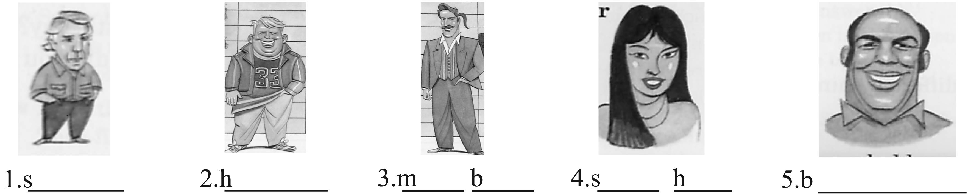
(41题图) (42题图) (43题图) (44题图) (45题图)
41. (Mr Green, short, with, hair)
42. (boy, short, heavy)
43. (his uncle, of, build)
44. (her sister, long, straight)
45. (old man, have, beard)

B) 根据情景，从方框中选择适当的句子将对话补充完整。（5分）
A. Is she beautiful?
B. Does she always wear a white dress?
C. What does she look like?
D. Can you tell me her name?
E. Is she tall?
A: I have a new friend in my class.
B: Really? 46__________
A: She has long straight hair.
B: 47__________
A: Yes. She’s as tall as 162cm.
B: 48__________
A: Of course. She has two big bright eyes and a good-looking face.
B: 49__________
A: Yes, that’s her.
B: I often see her at school. 50__________
A: Emily. She comes from Hong Kong.
B: Her parents must be working in our city.
A: Yes, I think so.
Ⅵ.句型转换，每空一词。（10分）
51. Ann is short. She has long straight hair. (合并为一句)
Ann is short _______ long straight hair.
52. Michael Jackson is tall and thin. (对画线部分提问)
_______ does Michael Jackson _______ _______?
53. Tony is of medium height. (改为同义句)
Tony is not _______ and not _______.
54. Everybody knows Amy in Beijing and Guangzhou. (改为反意句)
_______ _______ Amy in Beijing and Guangzhou.
55. I think Mary is cool. (改为否定句)
I _______ think Mary _______ cool.

Ⅶ.用方框里适当的单词或短语完成句子。（10分） 
hair, height, never, old, newspaper, play, but, can’t, get, glasses, scarf, build
My grandfather is seventy years old, 56________ he is still very healthy. He is tall and of medium 57________. He has short straight white 58________. He likes reading. Every morning he 59________ up very early and then reads morning 60________. When he reads, he always wears 61________. He also likes 62________ chess, too. He always plays chess with his 63________ friends. He 64________ plays chess with me. Why? Because I 65________ play chess.

Ⅷ.书面表达（20分）
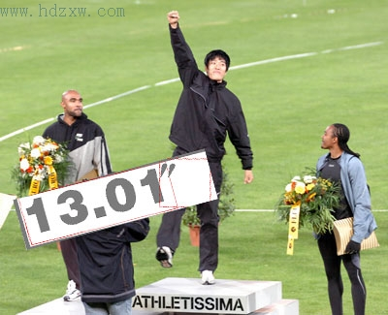
根据表格中的信息及提示词汇写一段60词左右的短文，介绍一下刘翔，要写出他的外貌特征、衣着、爱好等情况。
姓名 | 刘翔 | 身高 | 1.88米
性别 | 男 | 体重 | 74公斤
出生日期 | 1983.7.13 | 个人爱好 | 唱歌、电脑
提示词汇：体育明星a famous sports star；奥运会 Olympic Games；获胜 win

参考答案:
Ⅰ.1-5 CABCC 6-10 ABCBB
Ⅱ.11-15 ABCCA 16-20 BBBAC
Ⅲ.A) 21-25 CBCAB
B) 26. very thin 27. short straight hair 28. a little bit heavy 29. long straight hair
30. of medium build
Ⅳ.A) 31. captain 32. remember 33. person 34. build 35. pop
B) 36. look 37. glasses 38. singer 39. has 40. jokes
Ⅴ. A) 41. Mr Green is short with short hair. 42. The boy is short and a little bit heavy.
43. His uncle is of medium build. 44. Her sister has long straight hair.
45. The old man has a beard.
B) 46-50 CEABD
Ⅵ.51. with 52. What; look like 53. tall; short 54. Nobody knows 55. don’t; is
Ⅶ.56. but 57. build 58. hair 59. gets 60. newspapers 61. glasses 62. playing 63. old
64. never 65. can’t
Ⅷ. One possible version:
Liu Xiang is a sports star. He is very popular in China and also in the world. He is 25. He is very tall and of medium build. He has short black straight hair. And he has small eyes and a big nose. He likes singing and playing computer games. In the picture, he is wearing black sports clothes and white sports shoes. We hope he can win in 2008 Olympic Games.

